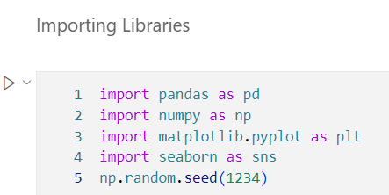

There are 180 rows and 9 columns.

**Dataset Overview:**

1. **Product**:

* The treadmill model purchased.
* Categories: KP281 (entry-level, $1,500), KP481 (mid-level, $1,750), and KP781 (advanced, $2,500).

1. **Age**:

The age of the customer in years.

1. **Gender**:

* The gender of the customer.
* Categories: Male, Female.

1. **Education**:

The number of years of education completed by the customer.

1. **MaritalStatus**:

* The marital status of the customer.
* Categories: Single, Partnered.

1. **Usage**:

The average number of times per week the customer plans to use the treadmill.

1. **Fitness**:

* The self-rated fitness level of the customer on a 1–5 scale.
* Scale: 1 (poor shape) to 5 (excellent shape).

1. **Income**:

The annual income of the customer is in USD.

1. **Miles**:

The average number of miles the customer expects to walk or run per week.

There are no missing values and duplicate values in this dataset.

**Descriptive Analysis:**

**Numerical Variables Interpretation:**

The dataset provides valuable insights into the characteristics of customers who purchased treadmills. The average **age** of buyers is approximately 29 years, with most falling within the young adult demographic, ranging from 18 to 50 years. Notably, 75% of customers are aged 33 or younger, indicating a strong appeal among younger, fitness-conscious individuals.

In terms of **education**, most customers have around 16 years of schooling, equivalent to a college degree, with education levels ranging from high school graduates to individuals with advanced degrees. This suggests a relatively well-educated customer base, which may influence their purchasing decisions and preference for health and fitness products.

When considering **usage**, customers plan to use the treadmill an average of 3–4 times per week, with a range spanning from twice weekly to daily use. This moderate to high level of engagement highlights the potential for sustained use of the product, particularly among those who prioritize fitness routines.

Regarding **fitness levels**, most customers rate themselves around 3 on a 1–5 scale, indicating moderate fitness. While there is some variability, a significant proportion of buyers rate their fitness as average to good, aligning with their intent to improve or maintain their fitness levels.

The annual **income** of customers averages around $53,720, with values ranging from $29,562 to $104,581. This indicates that the treadmills cater to a broad spectrum of income groups, primarily targeting middle-income earners. A quarter of customers earn less than $44,059, while another quarter earns over $58,668, reflecting a mix of affordability and aspirational spending.

Finally, customers expect to cover an average of 103 miles weekly, with distances ranging from 21 to 360 miles. This wide variability underscores the product's appeal to both casual users and highly active runners. Most customers anticipate walking or running between 66 and 115 miles per week, suggesting a strong demand for treadmills that accommodate varying fitness levels and goals.

**Insights:**

The dataset reveals a customer base of young, educated, and fitness-oriented individuals with moderate to high levels of engagement, predominantly drawn from middle-income groups. These insights will guide the identification of target segments and tailored marketing strategies.

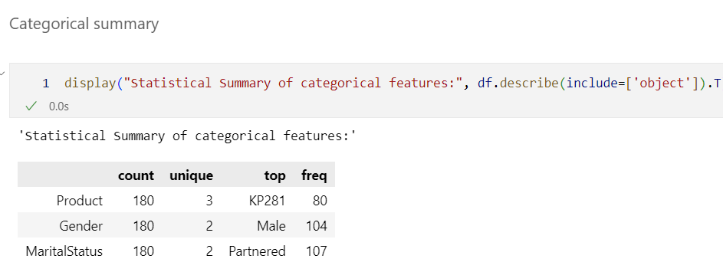

**Categorical Variables Interpretation:**

The dataset reveals interesting patterns in the categorical variables related to treadmill purchases. Product data shows that most customers opted for the KP281 model, with 80 out of 180 customers purchasing it, making it the most popular choice. This entry-level treadmill seems to have broad appeal, likely due to its affordability or basic features that cater to a larger customer base. In comparison, the other two models, KP481 and KP781, were less frequently purchased, highlighting a stronger preference for the more economic option.

Regarding Gender, the dataset indicates that male customers make up the majority, with 104 male customers purchasing a treadmill, compared to 76 female customers. This suggests that the product may have a slightly stronger appeal to male buyers, or it could reflect broader purchasing trends in the fitness market. However, the presence of both genders indicates a reasonably balanced target audience for the treadmills.

When examining MaritalStatus, most customers are partnered, with 107 out of 180 customers falling into this category. This is a significant proportion compared to the 73 single customers. The higher purchase rate among partnered individuals could suggest that those in relationships may be more likely to invest in fitness equipment, possibly driven by shared health goals or the desire for family-oriented activities.

**Insights:**

The dataset reveals that the KP281 treadmill is the most popular among both male and partnered customers. These insights can guide marketing strategies by emphasizing the treadmill’s appeal to these key customer segments.

**Non-Graphical Analysis:**

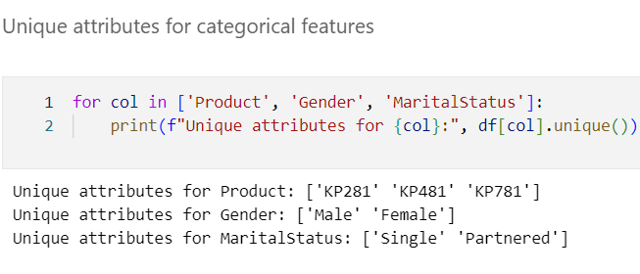

**Graphical Analysis:**

**Univariate Analysis:**

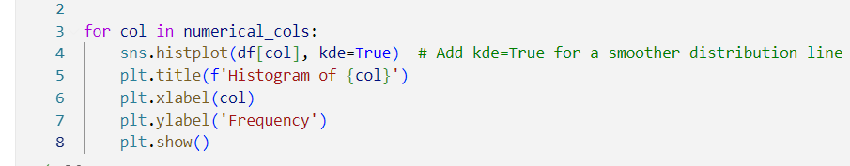

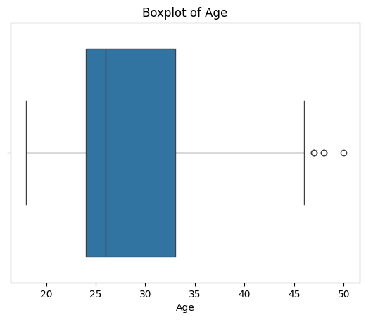

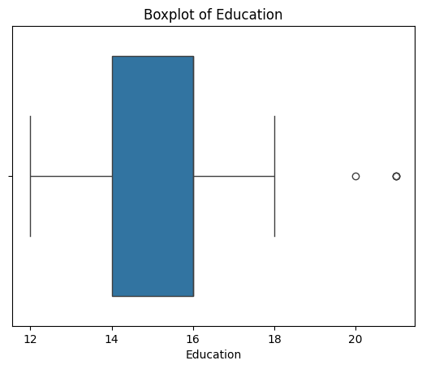

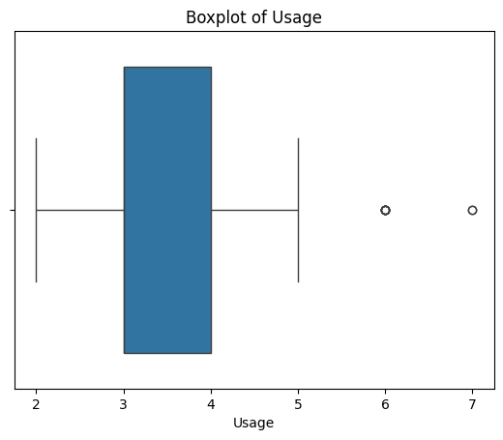

**Interpretation:**

All the variables have almost normal distribution, but income and miles have more outliers in this dataset. As the dataset is very small so I choose not to remove the outliers.

**Interpretation:**

The highest number of treadmill category purchased is K281. Most of your customers are male. The top marital status is partnered.

**Bivariate Analysis:**

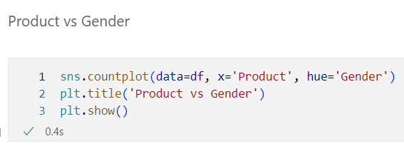

KP281 have highest male and female customers showing that this product is highly in demand among both genders.

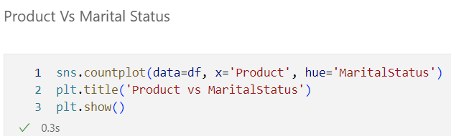

Similarly, as we know above there are more partnered people in marital status and highest sold product is also KP281 hence that trend proving here as well.

The age group which purchased the most of KP281 is 21-40. Also most of the customers are in this age group of 21-40.

**Multivariate Analysis:**

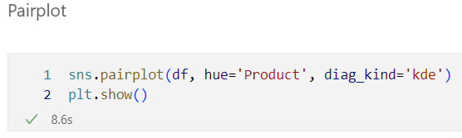

**Correlation Analysis:**

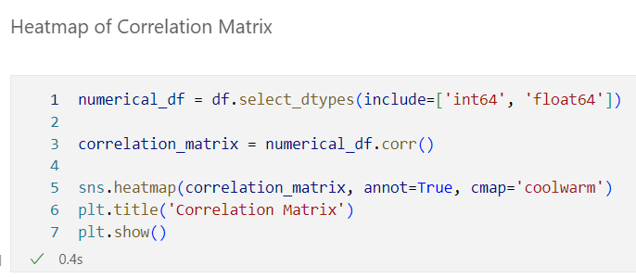

**Observation and Insights:**

The correlation matrix reveals several important relationships between the variables. The strong positive correlation between Fitness and Miles (0.79) suggests that individuals with higher fitness levels tend to engage in activities requiring more mileage, such as running. Similarly, the strong correlation between Usage and Miles (0.76) implies that higher utilization of a product or service leads to greater mileage, potentially reflecting frequent engagement in physical activities. Income demonstrates moderate positive correlations with Education (0.63), Usage (0.52), and Fitness (0.54), indicating that higher income levels are linked to better education, increased usage of services, and improved fitness levels, likely due to access to resources and opportunities. In contrast, Age exhibits weak correlations with most variables, with its strongest relationship being with Income (0.51), suggesting a mild trend where older individuals might earn higher incomes. The negligible correlations of Age with Usage (0.015) and Age with Fitness (0.061) indicate that age has minimal impact on these factors. Overall, the matrix highlights key dependencies, particularly between fitness, usage, and mileage, while also pointing out the limited influence of age on these variables.

**Outlier Detection:**

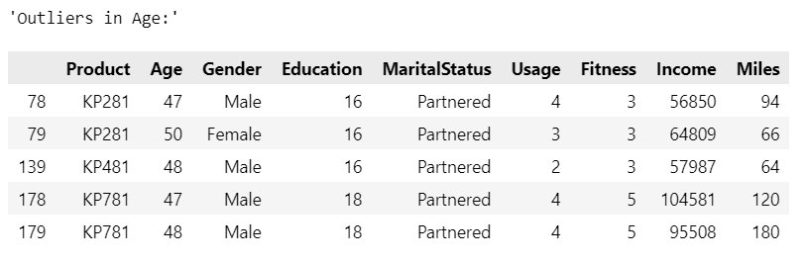

**Conditional Probabilities:**

**Insights:**

1. **Product Distribution**:

* The most popular product is **KP281**, accounting for 44% of sales, followed by **KP481** (33%) and **KP781** (22%). KP281 dominates the market, indicating its broad appeal.
* KP781 has the smallest share, suggesting it caters to a more niche audience.

1. **Gender Distribution by Product**:

* KP281 has an equal distribution of male and female customers (50% each), indicating it appeals equally to both genders.
* KP481 has a slightly higher male customer base (52%) than female (48%), showing a slight skew towards male customers.
* KP781 is heavily dominated by male customers (82%), indicating it appeals predominantly to men.

1. **Age Distribution**:

* **64% of customers are aged 20–30**, highlighting that the primary target audience is young adults.

1. **Income Distribution**:

* **18% of customers are low-income**, which suggests the majority of customers are likely middle- or high-income earners.
* Only **12% of KP781 customers are high-income**, indicating this product’s appeal to higher-income groups is limited.

1. **Fitness Level Distribution**:

* Only **17% of customers have a fitness level of 5** (the highest level), showing a small segment of highly fit customers among the broader audience.

**Recommendations:**

1. **Targeted Marketing**:

* For **KP781**, focus marketing efforts on male customers and high-income individuals to strengthen its niche appeal. Highlight premium features and benefits to attract this audience further.
* For **KP281**, emphasize its broad appeal across genders, positioning it as a versatile product for everyone.

1. **Engage Young Adults**:

* With 64% of customers aged 20–30, develop marketing campaigns tailored to young adults. Use social media platforms, influencers, and fitness-related promotions to appeal to this demographic.

1. **Expand Reach to Women**:

* Since **KP781** has a low percentage of female customers (18%), consider strategies to make it more appealing to women, such as emphasizing features that align with their needs or preferences.

1. **Consider Affordability for Low-Income Groups**:

* With 18% of customers being low-income, introduce budget-friendly options or installment plans to expand access and appeal to this segment.

1. **Promote Fitness-Oriented Features**:

* Highlight the fitness benefits of the products, especially for **KP281** and **KP481**, to attract customers who value fitness.
* Create programs or partnerships encouraging customers to improve their fitness levels, particularly those in the lower fitness segments.

1. **Analyze KP781 Performance**:

* Since KP781 has the smallest market share (22%), it evaluates its pricing, features, and positioning. Identify why it appeals to a narrower audience and consider modifications to broaden its reach.